41. Implement a C Program Given a string - sort in alphabetical order
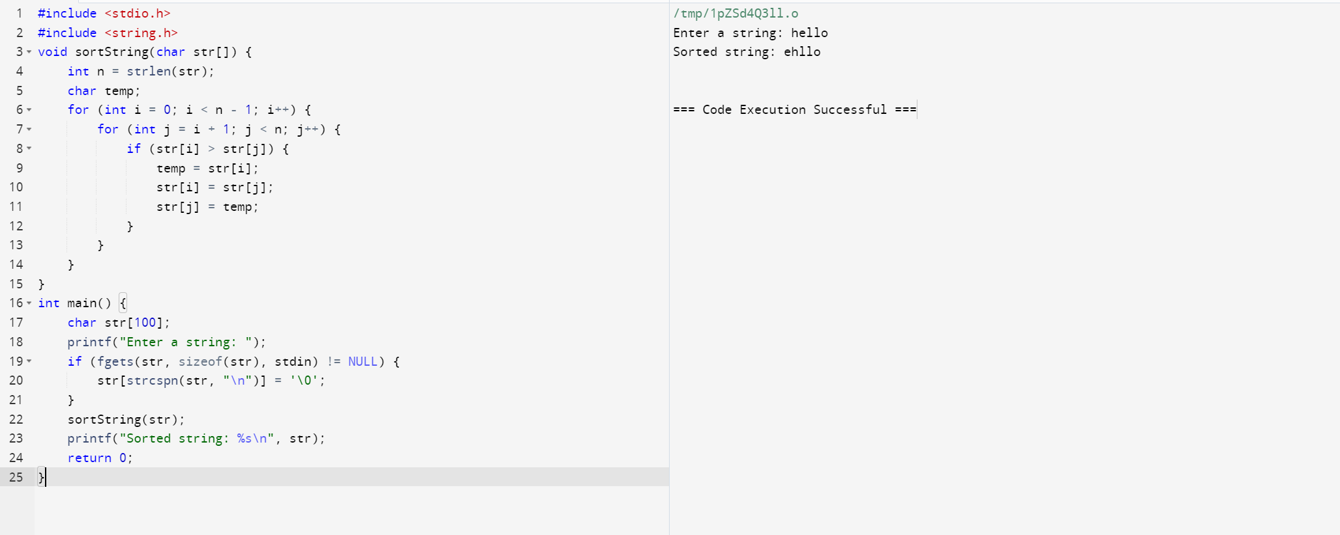
42. Implement a C Program to perform Bidirectional.
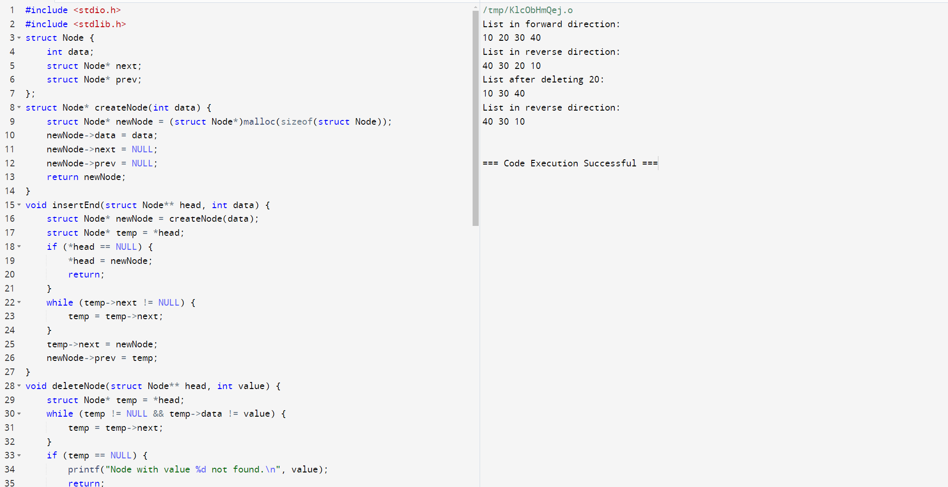
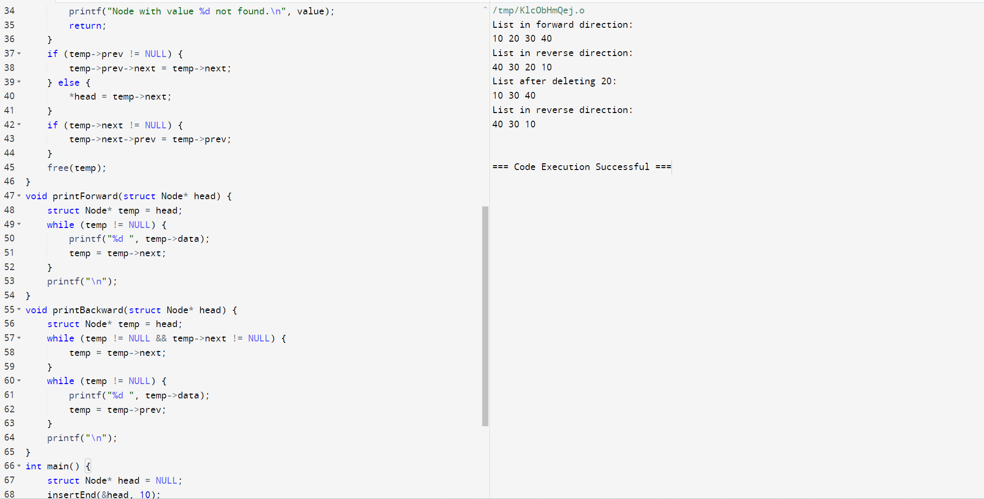
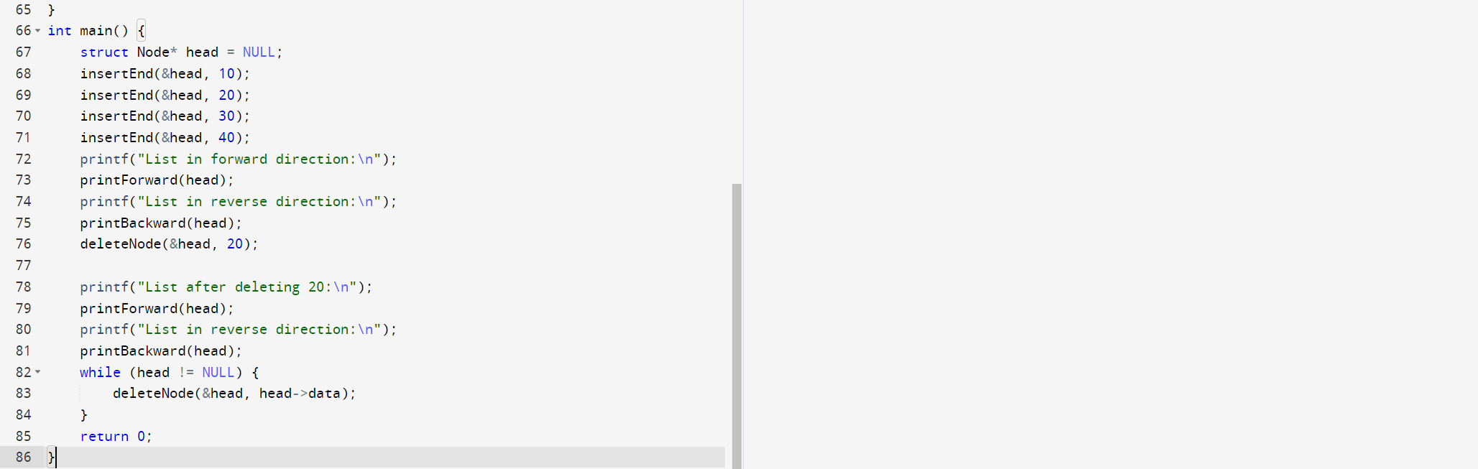
43. Implement a C Program to Print the frequently repeated numbers count from an array.
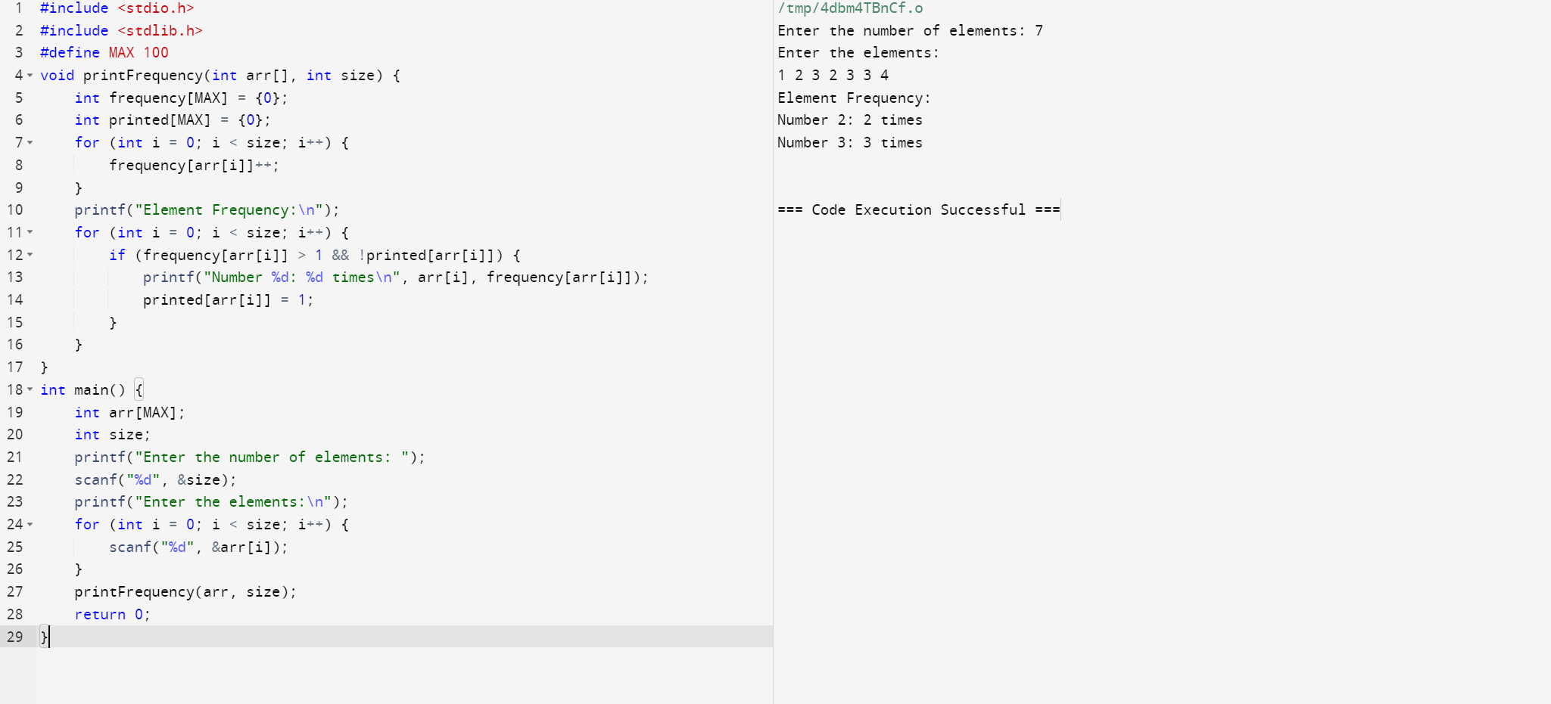
44.Implement a C Program to perform linked list – Deletion.
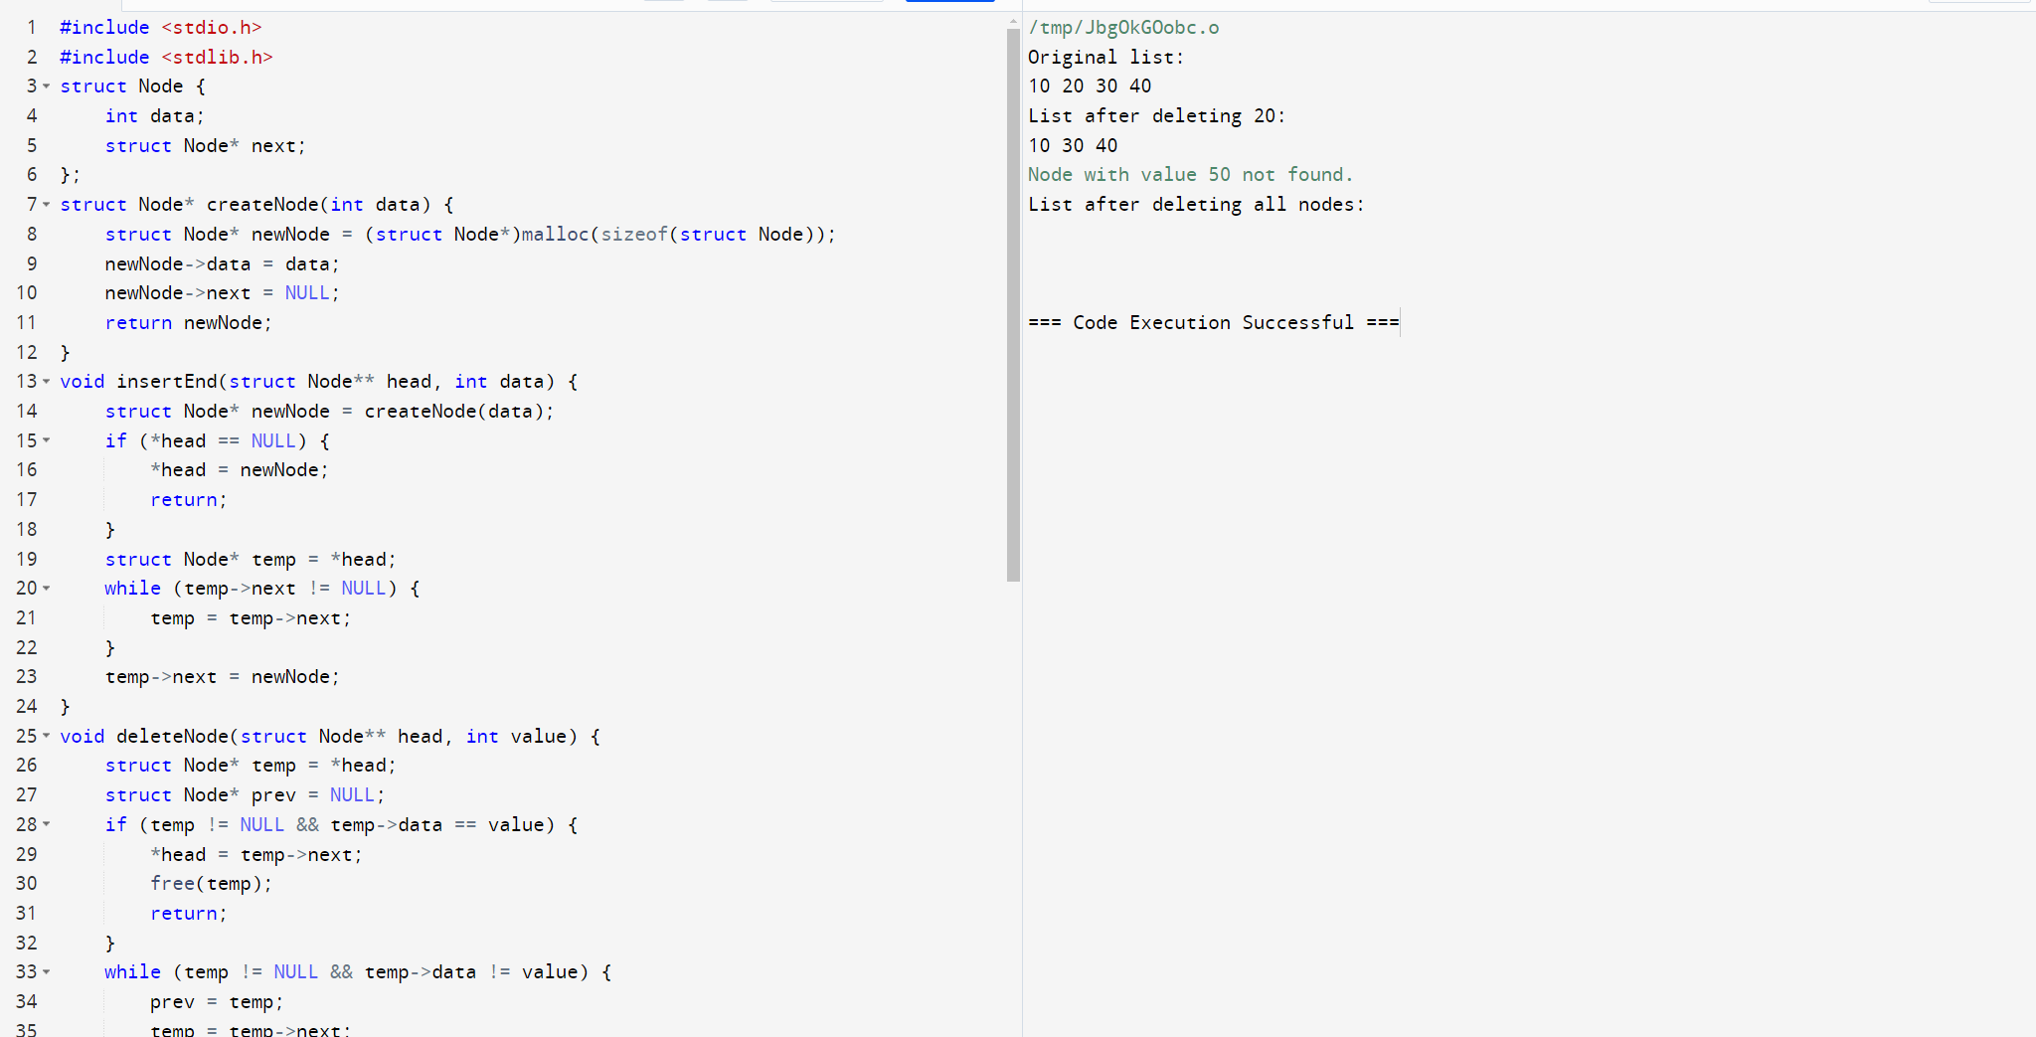
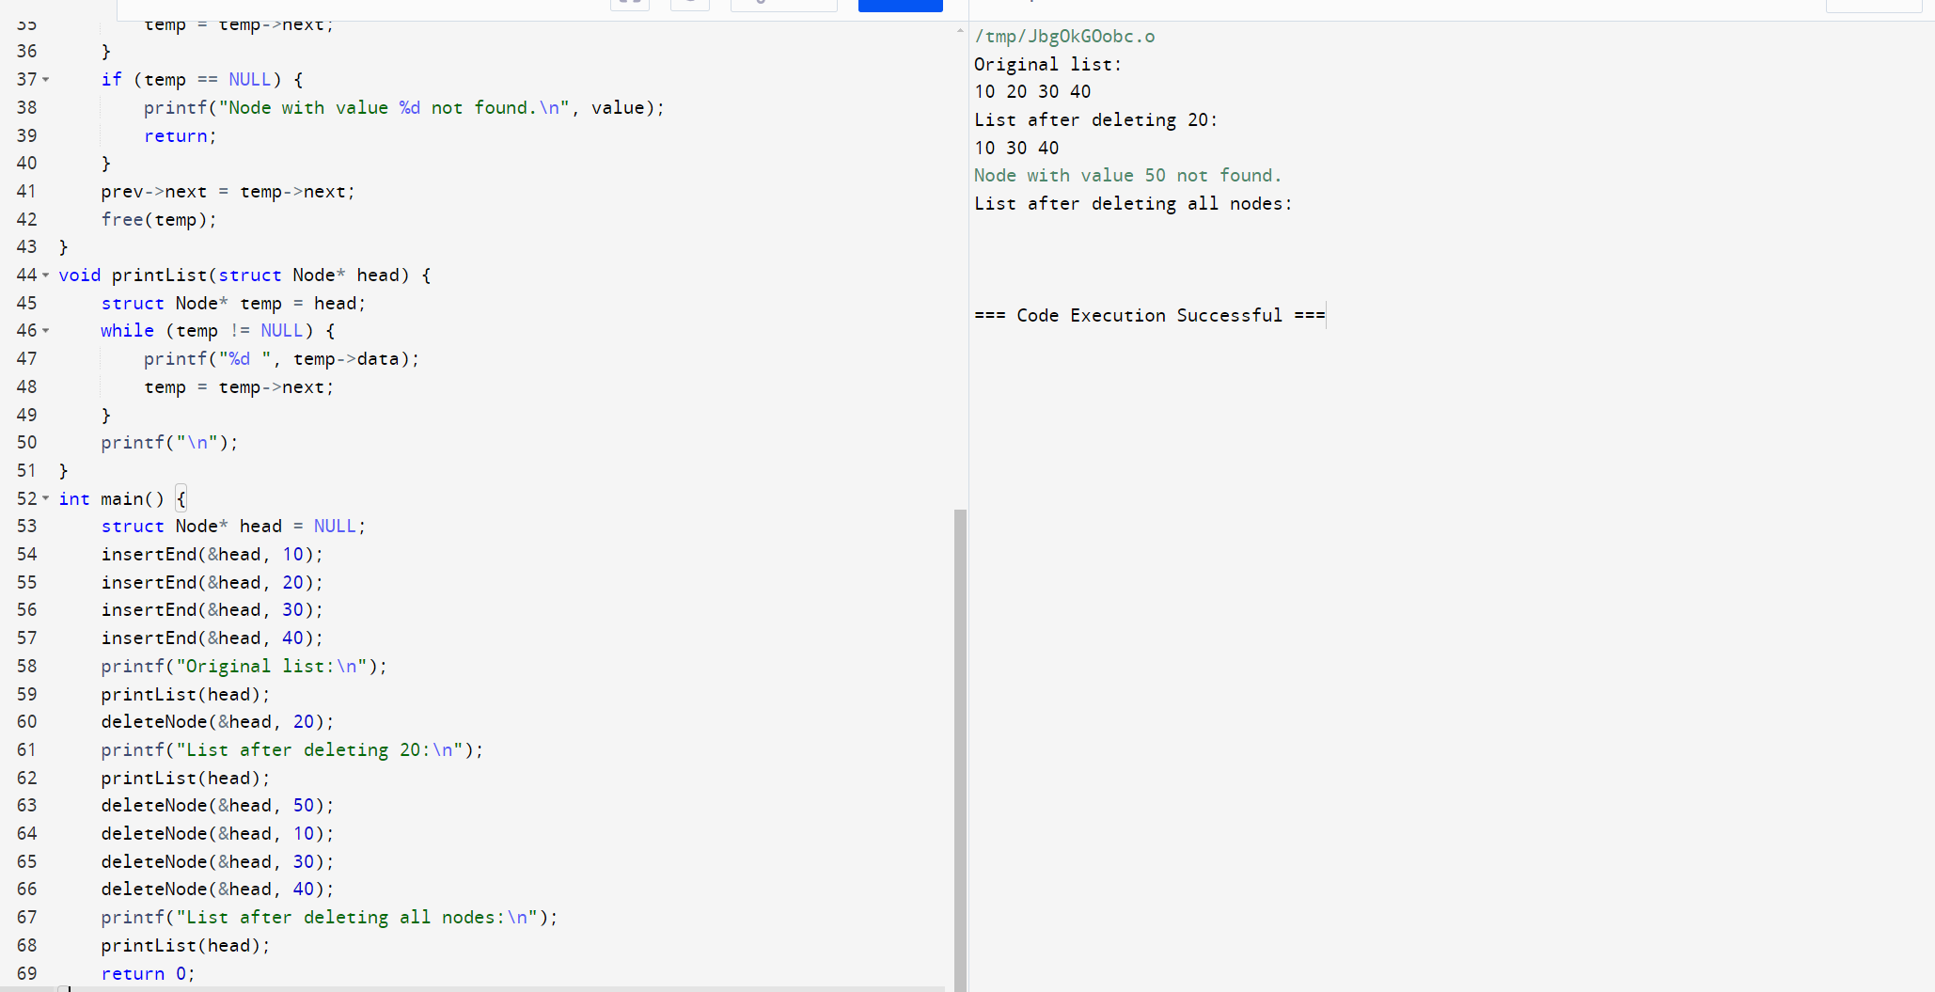
45. Implement a C Program to perform Sum of row and column in an Array.
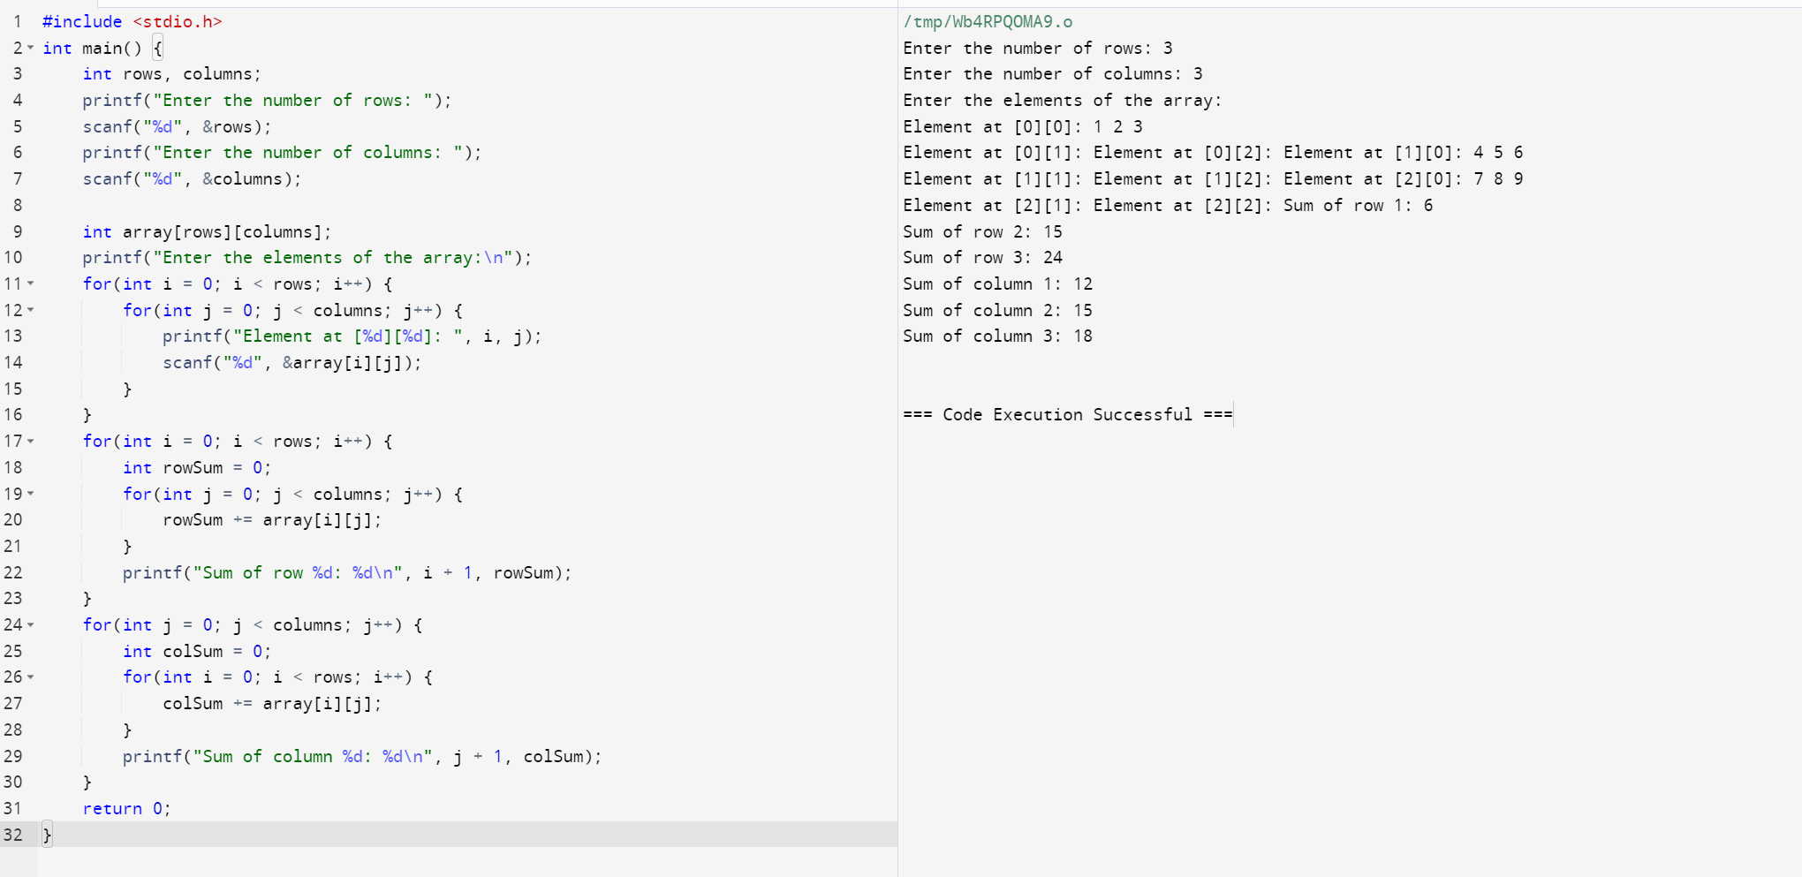

46. Implement a C Program to perform Tree traverse – Inorder.
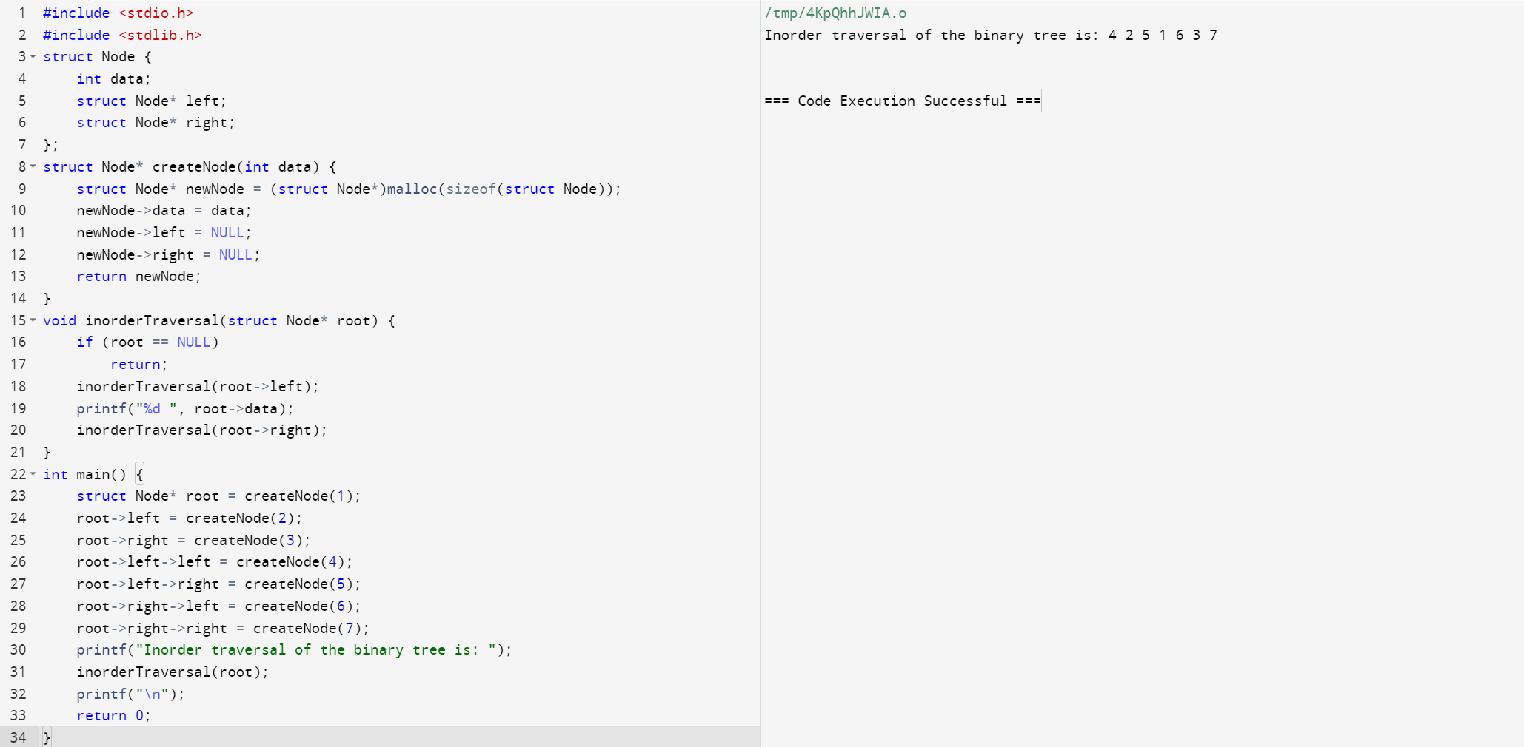

47. Implement a C Program to check for Elements repeated twice – Array
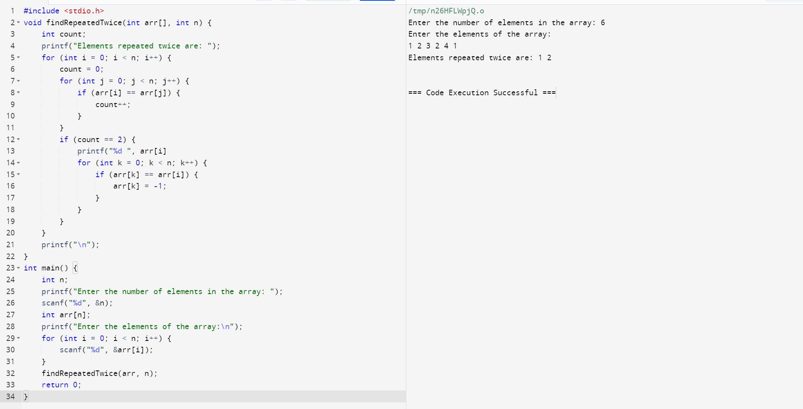
48. Implement a C Program for AVL tree – Insertion of Nodes.
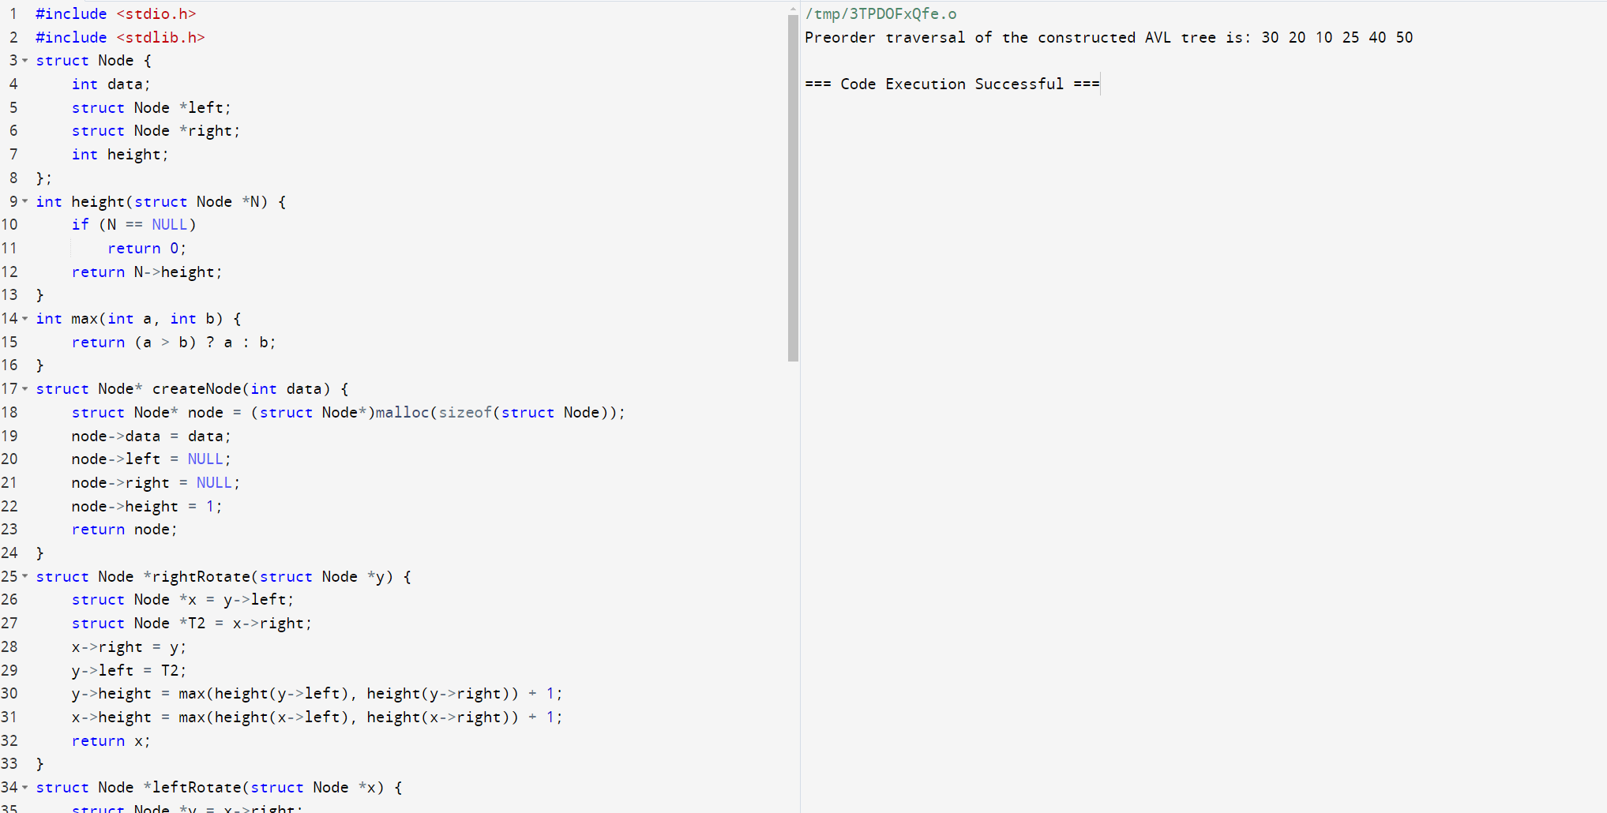
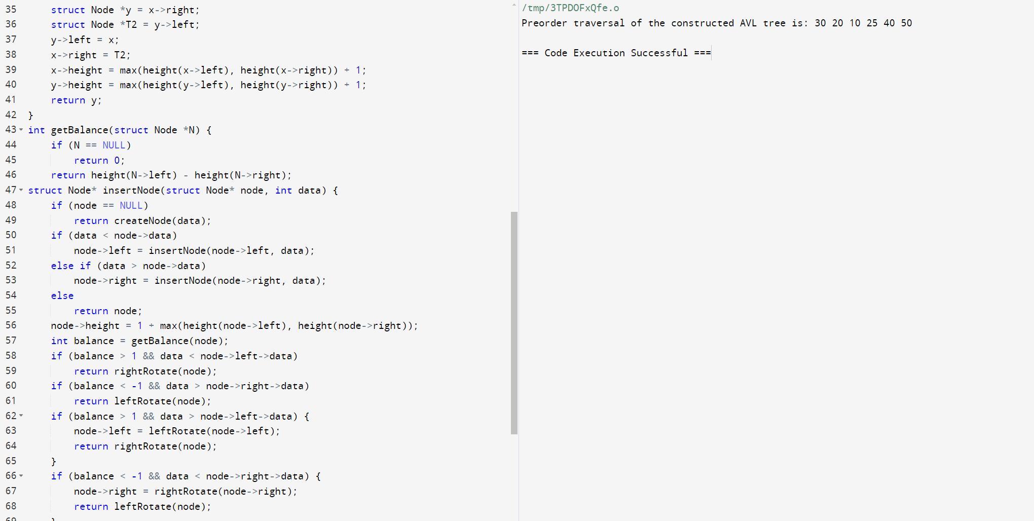
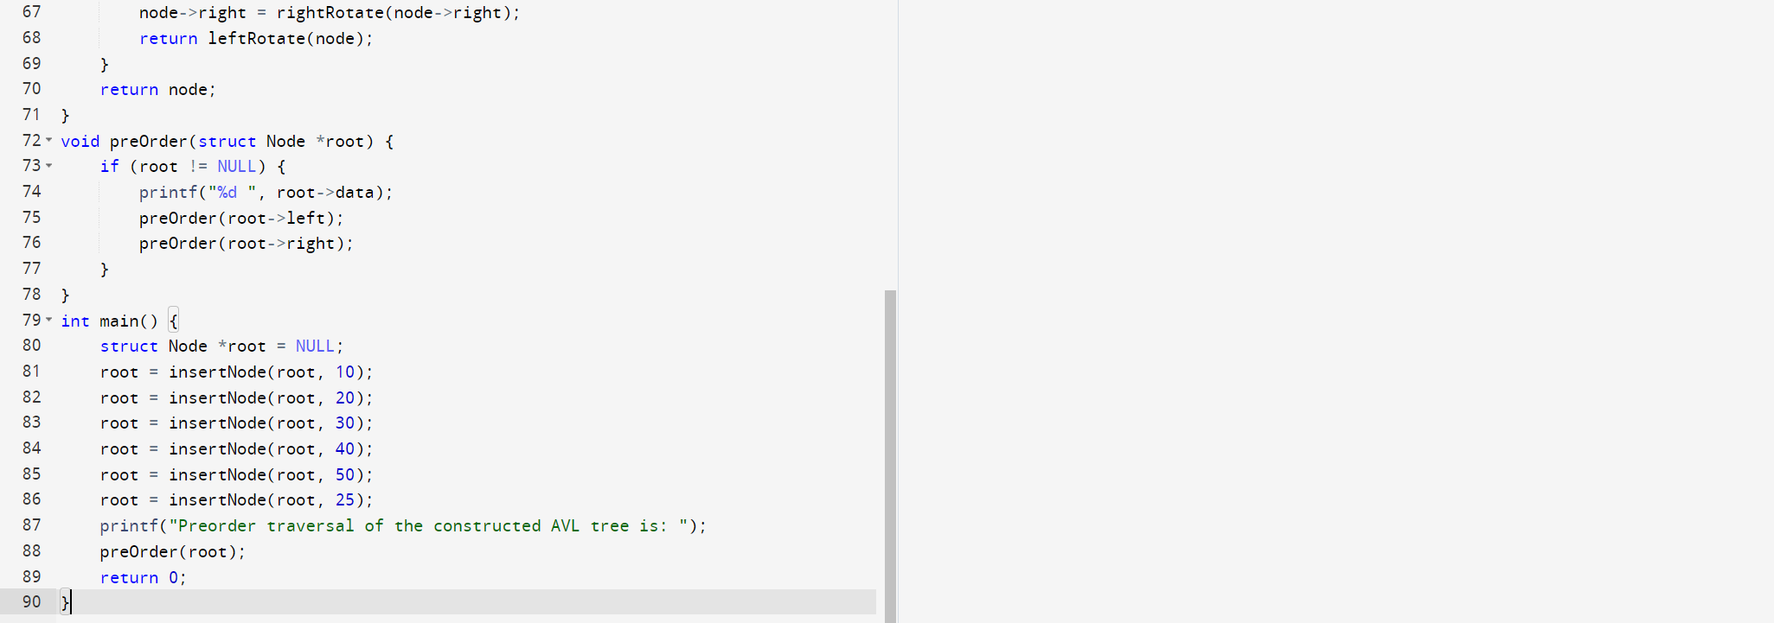
49. Implement a C Program Consider 2 stacks, add bottom most element and top
most element and print the value.
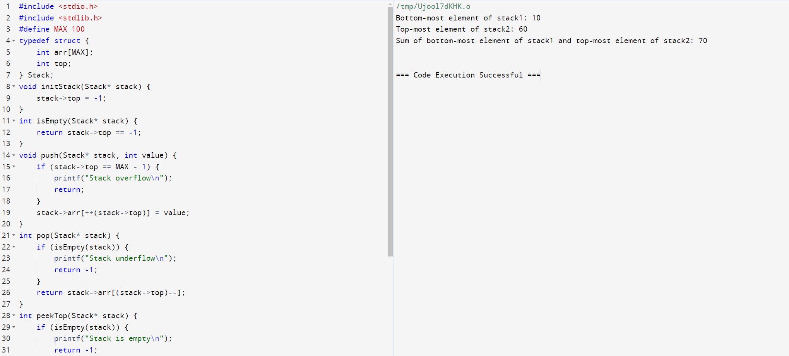
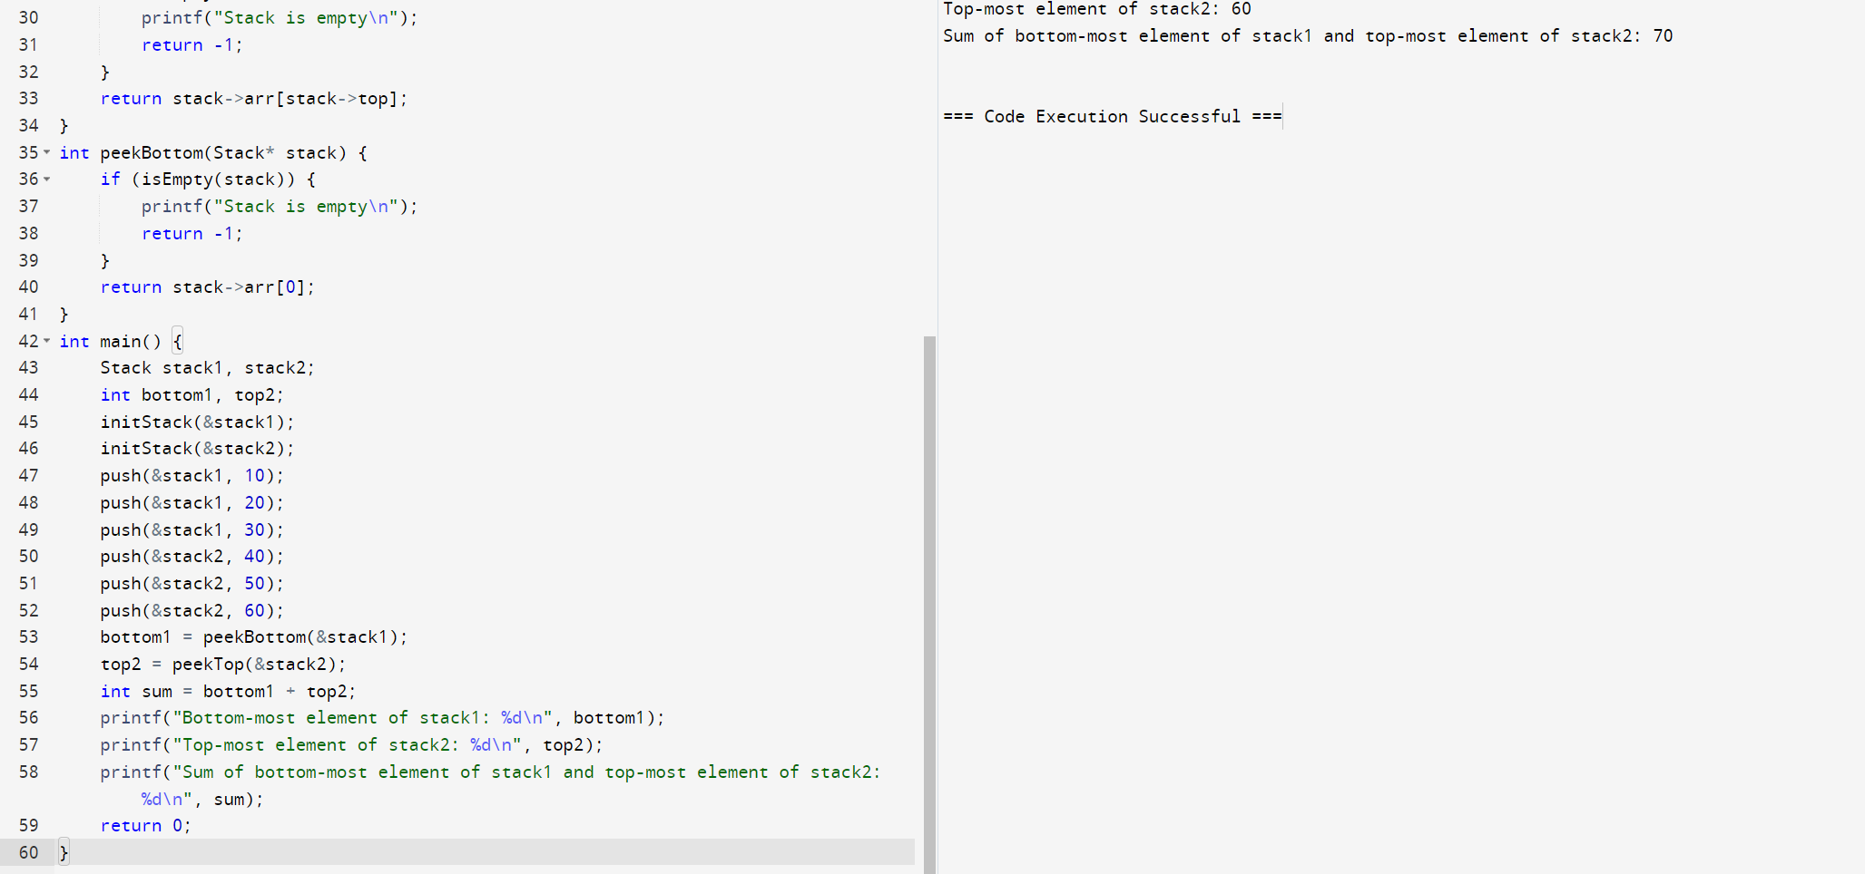
50. C program to print Factorial of a number without using Recursion.
